**Social Media Post Samples for Aging Network**

Help us tell Congress to support and increase funding for the Older Americans Act. Celebrating its 60th Anniversary, the Older Americans Act provides funding directly to local agencies serving older adults in our community with home delivered meals, congregate meals, family caregiver support, health and wellness programs, and social connections programs. Older Americans Act programs meet a critical need by helping older adults live independently in our community! [We invite you to read this letter from our Chief Executive Officer, released July 14th.](https://eciaaa.org/index.php/home/from-the-executive-director)

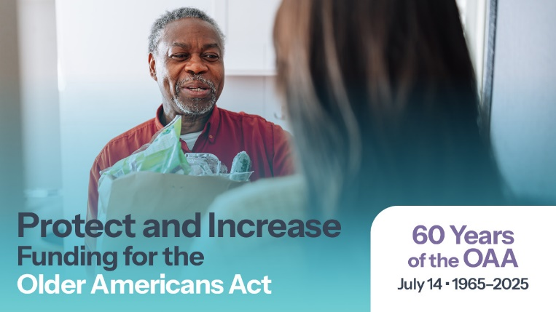**Facebook Images**

